# Requirements

### Stakeholder

### Developer

### Analyst

# The forms of data

## Sensitive Data Exposure

### Data in transit

### Data in processing

### Data at rest

### Structured Data

### Unstructured Data

### Confidentiality Requirement

# Integrity requirement

### Data Integrity*

### System Integrity*

### Availability requirement

### Authentication requirement

### Authorization requirement*

### Accountability requirement*

### General Requirements*

### Operational Requirements*

# Other Requirements

### Sequencing and timing

### International (or External) Requirement*

### Procurement Requirements*

# It Security design

### Security flaw

### Security bug

# Confidentiality Design cryptography

### Symmetric algorithms

### Assymetric algorithms

# Integrity design

### Referential Integrity*

### Resource Locking

# Availability design

### Replication

### Failover

### Scalability

**Vertical:**

**Horizontal:**

# Attack surface evaluation

## Relative attack surface quotient (RASQ)

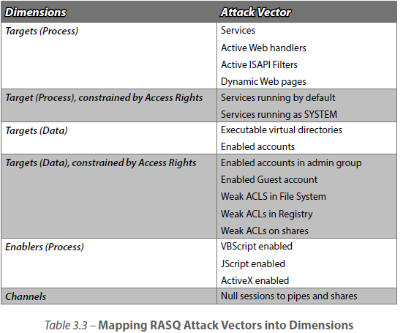

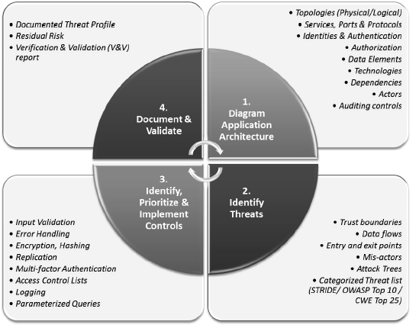

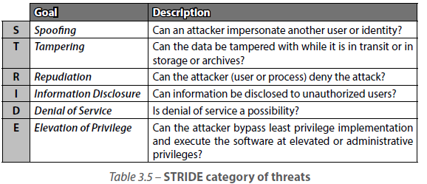

# Mainframe arhitecture

### Service Oriented Architecture (SOA)

# Rich Internet Applications (RIA)

# Representational State Transfer (REST)

# Cloud Computing

# Database Security

### Polyinstantiation

# Programming language environment

### Unmanaged

### Managed

### Compiler switches

# Operating Systems